ICEHA
Vietnam Program Update – March 2006

Between 2000 and 2005 the number of people living with HIV/AIDS in Vietnam has doubled.

ICEHA clinical mentoring enables local health care professionals to develop and hone the skills and knowledge they need to treat and prevent HIV/AIDS in their communities. As of February 2006, ICHEA clinical mentors in Vietnam have provided 6800 hours of bed-side mentoring to local health professionals in 8 different medical settings.
Achievements
- 6800 hours of clinical mentoring provided in Vietnam
- 8 different settings
- One clinic “mentored out”

Goals
- Many more health centers waiting for ICEHA clinical mentors across 59 provinces
- Lasting benefits are greater after a series of mentoring teams coach at each site – ongoing presence is necessary for optimal results
- For all HIV clinics to become “mentored out”

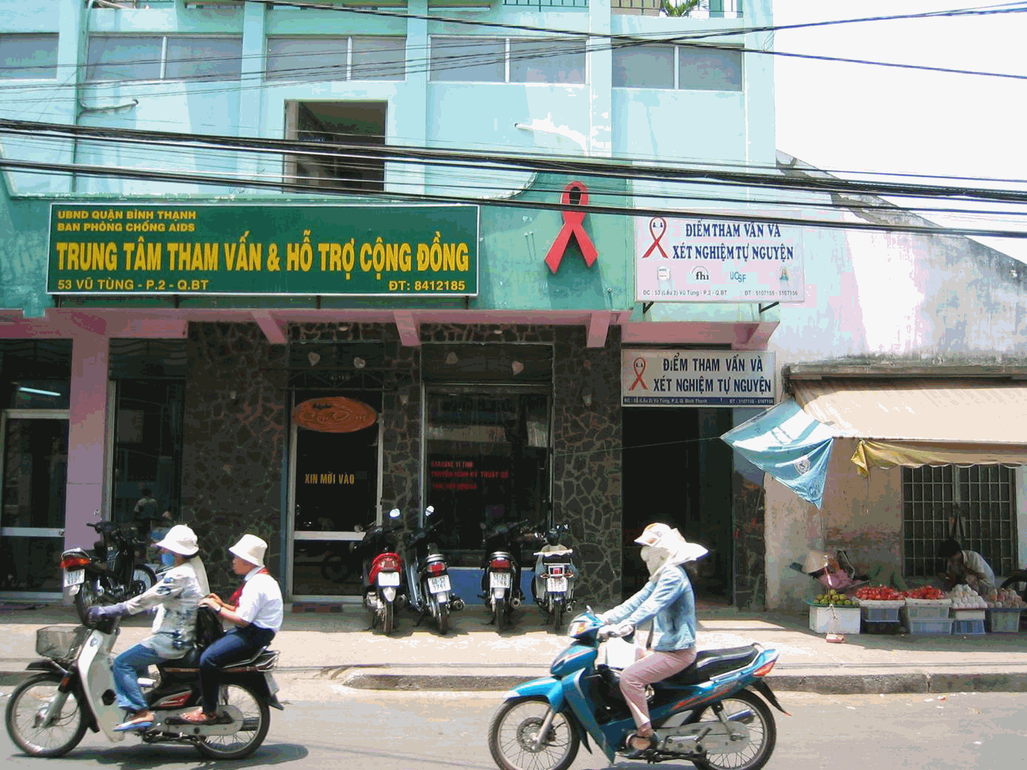
Some of the settings are in urban locations while others are in rural areas that serve the indigenous populations. In just one urban clinic, there are now 1500 patients receiving treatment for HIV. This clinic opened only one year ago. Now, instead of watching their patients die they see them live longer, healthier and more productive lives. Their patient load is growing but they now have the skills, developed under the guidance of ICEHA clinical mentor teams, to take care of their HIV-infected patients on their own.
HIV Clinic with a rapidly growing patient population
Ho Chi Minh City, Vietnam

ICEHA Clinical Mentors in Vietnam have had an impact on the level of care provided to HIV-infected patents that has immediate as well as long-term benefits. ICEHA’s goal is to provide clinical mentoring across all 59 districts of Vietnam.

For more information visit: www.iceha.org

